Pollen’s Profiling: Automated Classification

of Pollen Grains

# By:

Team ID: LTVIP2025TMID21087

Team Leader: Gandu Kavya

Team member: Dudekula Giri Babu

Team member: Dodda Hemanth Reddy

Team member: Divi Anitha

# INTRODUCTION

## Project Overview

## *Pollen's Profiling* is a deep learning-based system designed to automate the classification of pollen grains using image processing and convolutional neural networks (CNNs). The project enables accurate identification of pollen types based on their morphological features and supports key applications in environmental monitoring, allergy diagnosis, and agricultural research. It features a user-friendly web interface built with Flask for real-time image-based predictions.

## Purpose

## The purpose of *Pollen's Profiling* is to develop an intelligent, automated system for accurately classifying pollen grains using deep learning and image analysis. By replacing manual identification methods with a CNN-based model, the project aims to streamline environmental research, support allergy diagnosis, and enhance agricultural practices. It also provides a scalable and accessible web-based platform for real-time pollen analysis

# Ideation Phase

## Define the Problem Statements

|  |  |
| --- | --- |
| Date |  |
| Team ID | LTVIP2025TMID21087 |
| Project Name | Pollen's Profiling: Automated Classification of Pollen Grains |
| Maximum Marks | 2 Marks |

Manual identification and classification of pollen grains require expert analysis under a microscope, which is time-consuming and prone to human error. This project addresses this challenge by using deep learning models to automatically classify pollen types based on image features, enabling faster, more accurate identification for use in environmental monitoring, allergy diagnosis, and agricultural research.

|  |  |  |  |  |  |
| --- | --- | --- | --- | --- | --- |
| **Problem Statement (PS)** | **I am (Customer)** | **I’m trying to** | **But** | **Because** | **Which makes me feel** |
| PS-1 | An environmental researcher | identify and classify pollen species quickly | manual identification is slow and complex | it requires microscopic analysis and expert skills | overwhelmed and time-constrained |
| PS-2 | A healthcare professional | detect allergenic pollen types in patient environments | traditional methods lack real-time accuracy | pollen samples require lab analysis and expert review | delayed and uncertain |
| PS-3 | An agricultural scientist | monitor crop-specific pollen for research | manual pollen sorting is tedious | high sample volume and seasonal constraints | limited in efficiency and scope |

## Empathize & Discover

|  |  |
| --- | --- |
| Date |  |
| Team ID | LTVIP2025TMID21087 |
| Project Name | Pollen's Profiling: Automated Classification of Pollen Grains |
| Maximum Marks | 4 Marks |

**The empathy map outlines user concerns and behaviors:**

* **Says:** "I want quick and accurate pollen identification without needing a microscope."
* **Thinks:** "Is this pollen harmful? Can I rely on this system’s prediction?"
* **Does:** Uploads pollen grain images for analysis through the web app.
* **Feels:** Curious about the results, concerned about allergies or crop impact.

|  |  |  |
| --- | --- | --- |
|  | What does the user **THINK & FEEL?**   * Worries about allergic reactions or crop failures. * Wonders if the system’s classification is accurate and scientifically valid * Fears misclassification or delays in identification |  |
| What does the user **SEE**?   * Sees microscopic pollen images that are hard to interpret * Online tools with complex steps or requiring lab expertise * Lack of simple,accessible platforms for pollen analysis |  | What does the user **HEAR**?   * Researchers discussing pollen identification challenges * Health experts warning about rising pollen-related allergies * Farmers or allergists seeking reliable pollen insights |
| **PAIN**   * Manual analysis is slow and requires microscopy expertise * Difficulty in identifying allergens or matvhing species visually * Crop research delayed due to seasonal sample processing limitations |  | **GAIN**   * Automated and fast pollen classification from images * Early detection of allergenic pollen support better health decisions * Saves time for researchers and improves agricultural planning |

## Brainstorm & Idea Prioritization

|  |  |
| --- | --- |
| Date |  |
| Team ID | LTVIP2025TMID21087 |
| Project Name | Pollen's Profiling: Automated Classification of Pollen Grains |
| Maximum Marks | 4 Marks |

**We brainstormed various ideas:**

* Automated pollen classification using deep learning
* Visual representation of pollen grain predictions
* Image upload feature for microscope-captured samples
* Expert review option for validating model predictions

We prioritized deep learning-based pollen classification with optional image upload support through a user-friendly web interface.

| **Idea Area** | **Potential Solutions** |
| --- | --- |
| User Input Method | Design a simple and intuitive UI to upload pollen grain images captured via microscope. |
| Prediction Method | Use deep learning models such as Convolutional Neural Networks (CNNs) for accurate classification. |
| Accessibility | Deploy the application using Flask and host it online so it can be accessed from any device. |
| Ease of Understanding | Display the predicted class along with visual confirmation and short biological descriptions. |
| Data Handling | Automatically resize and preprocess uploaded images to match model input requirements. |

# REQUIREMENT ANALYSIS

## Customer Journey Map

|  |  |
| --- | --- |
| Date |  |
| Team ID | LTVIP2025TMID21087 |
| Project Name | Pollen's Profiling: Automated Classification of Pollen Grains |
| Maximum Marks |  |

1. User visits the web application link
2. User uploads an image of a pollen grain captured via microscope
3. CNN model processes the image and predicts the pollen type
4. System displays the predicted class along with a description and sample image

|  |  |  |  |  |
| --- | --- | --- | --- | --- |
| **Stage** | **Customer Action** | **Touchpoint** | **Emotion** | **Improvement Opportunity** |
| **Awareness** | Hears about the tool from researcher/colleague | Word of mouth/social media | Hopeful | Promote through academic and environmental platforms |
| **Consideration** | Visits the pollen profiling web app | Landing page | Curious | Add intro/demo video explaining how it works |
| **Input** | Uploads pollen grain image | Web UI (upload page) | Anxious | Provide hints/tooltips for proper image submission |
| **Prediction** | Receives predicted pollen class | Model output | Relieved or uncertain | Show class label, sample comparison, and description |
| **Follow-up** | Uses result in research/diagnosis/agriculture | Downloadable result | Empowered | Enable image-based report export/share option |

## Solution Requirements (Functional & Non-functional)

|  |  |
| --- | --- |
| Date |  |
| Team ID | LTVIP2025TMID21087 |
| Project Name | Pollen's Profiling: Automated Classification of Pollen Grains  Top of Form  Bottom of Form |
| Maximum Marks | 4 Marks |

### ****Functional Requirements:****

* User uploads an image of a pollen grain through the web interface
* Model processes the image and provides the predicted pollen class
* Output includes the class label and a brief description of the pollen type
* Optional: Allow viewing of example images for each class for reference

### ****Non-Functional Requirements:****

* Fast and responsive web interface for smooth user interaction
* Portable and accessible across various devices (desktop, tablet, mobile)
* Secure handling of uploaded images without storing them permanently on the server

| Requirement Type | Description |
| --- | --- |
| Functional | User should be able to upload an image of a pollen grain for classification. |
| Functional | System must resize, preprocess, and classify the image using the trained CNN model. |
| Functional | System must display the predicted pollen class along with a brief description. |
| Functional | Optionally allow comparison with example images of the predicted class. |
| Non-Functional | Prediction result should be generated in under 3 seconds. |
| Non-Functional | Web interface should be responsive and accessible on desktops, tablets, and mobile devices. |
| Non-Functional | Uploaded images should be processed in real-time and not stored permanently. |

## Data Flow Diagram

|  |  |
| --- | --- |
| Date |  |
| Team ID | LTVIP2025TMID21087 |
| Project Name | Pollen's Profiling: Automated Classification of Pollen Grains |
| Maximum Marks | 4 Marks |

## User Uploads Image → Flask Server → Image Preprocessing (Resize & Normalize) →

## CNN Model → Pollen Class Prediction → Result Rendered on Web Interface

## Technology Stack

|  |  |
| --- | --- |
| Date |  |
| Team ID | LTVIP2025TMID21087 |
| Project Name | Pollen's Profiling: Automated Classification of Pollen Grains |
| Maximum Marks | 4 Marks |

| **Component** | **Description** | **Technology Used** |
| --- | --- | --- |
| Frontend | User Interface | HTML, CSS (via Flask templates) |
| Backend | Server logic and routing | Python, Flask |
| ML Model | Image classification engine | CNN (TensorFlow/Keras) |
| Preprocessing | Image resizing and normalization | OpenCV, NumPy |
| Deployment | Hosting the web application | GitHub, Render / Localhost |

1. **PROJECT DESIGN**

## Problem Solution Fit

|  |  |
| --- | --- |
| Date |  |
| Team ID | LTVIP2025TMID21087 |
| Project Name | Pollen's Profiling: Automated Classification of Pollen Grains |
| Maximum Marks | 2 Marks |

### The current challenge in pollen analysis lies in the slow, manual identification of pollen types, which requires expert knowledge and specialized lab equipment. This project bridges the gap by offering a fast, AI-powered image classification system accessible through a web-based interface, supporting researchers, doctors, and farmers alike.

### Target Customer

### Environmental scientists monitoring biodiversity and ecosystem changes

### Allergists and healthcare professionals diagnosing pollen allergies

### Agricultural researchers studying pollination and plant reproduction

### Students, educators, and citizen scientists working with pollen samples

### Current Behavior (Without the Solution)

* Researchers manually classify pollen under microscopes, which is time-consuming
* Limited tools for quick or remote pollen identification
* Allergy diagnosis lacks instant identification of environmental allergens
* Farmers face delays in analysing pollen samples for breeding or crop assessment

### Pain Points

### Manual classification is slow, error-prone, and requires microscopy expertise

### Inaccessibility of tools for non-experts or rural/agricultural areas

### Lack of real-time or portable systems for on-site pollen identification

### Difficulty in visually comparing pollen species without expert help

### Proposed Solution

### A web-based tool where users can upload a pollen grain image (captured through a microscope), which is then analyzed by a trained CNN model. The system automatically classifies the pollen type and displays the result along with a visual reference and brief description for context.

### Benefits / Improvements

* Instant pollen classification using deep learning
* No need for specialized equipment or expert lab access
* Accelerates allergy diagnosis, biodiversity monitoring, and crop research
* Empowers non-experts and supports educational use
* Browser-accessible and easy to deploy across platforms

## Proposed Solution

|  |  |
| --- | --- |
| Date |  |
| Team ID | LTVIP2025TMID21087 |
| Project Name | Pollen's Profiling: Automated Classification of Pollen Grains |
| Maximum Marks | 2 Marks |

### Our solution includes:

A web-based predictive tool that allows users to upload images of pollen grains (captured via microscope). The system preprocesses the image and uses a deep learning model (CNN) to classify the pollen type. The result includes the predicted class label along with a simple description, making it accessible for researchers, healthcare professionals, and agricultural experts.

| **S.No.** | **Parameter** | **Description** |
| --- | --- | --- |
| **1** | Problem Statement (Problem to be solved) | Manual identification of pollen grains is slow, requires microscopy, and lacks scalability for widespread use. |
| **2** | Idea / Solution Description | A web-based deep learning tool that predicts pollen class from uploaded microscope images, offering real-time, accurate classification. |
| **3** | Novelty / Uniqueness | Combines CNN-based image recognition with an intuitive UI. Enables fast, expert-level classification accessible to anyone. |
| **4** | Social Impact / Customer Satisfaction | Aids allergy diagnosis, boosts agricultural research, enhances biodiversity studies, and empowers non-experts with advanced tools. |
| **5** | Business Model (Revenue Model) | Freemium web access with potential for premium features in research labs, hospitals, or agri-tech platforms. |
| **6** | Scalability of the Solution | Can expand to include more pollen types, support regional taxonomy, and deploy globally via cloud-based platforms. |

* 1. Solution Architecture

|  |  |
| --- | --- |
| Date |  |
| Team ID | LTVIP2025TMID21087 |
| Project Name | Pollen's Profiling: Automated Classification of Pollen Grains |
| Maximum Marks | 4 Marks |

The solution uses a modular structure:

* **Frontend (HTML + CSS via Flask templates):** Provides a user-friendly interface for uploading pollen grain images and viewing classification results.
* **Backend (Flask):** Handles image upload, preprocessing, and communicates with the trained CNN model to perform prediction.
* **ML Component (CNN Model - PollenModel.h5):** A pre-trained deep learning model processes the input image and classifies the pollen type based on learned features.
* **Image Preprocessing Module:** Resizes and normalizes uploaded images to match the input requirements of the CNN model.

# PROJECT PLANNING & SCHEDULING

## Project Planning

|  |  |
| --- | --- |
| Date |  |
| Team ID | LTVIP2025TMID21087 |
| Project Name | Pollen's Profiling: Automated Classification of Pollen Grains |
| Maximum Marks | 5 Marks |

**Product Backlog, Sprint Schedule, and Estimation (4 Marks)**

| **Sprint** | **Functional Requirement (Epic)** | **User Story Number** | **User Story / Task** | **Story Points** | **Priority** | **Team Member** |
| --- | --- | --- | --- | --- | --- | --- |
| Sprint-1 | Data Collection & Cleaning | USN-1 | As a user, I want to collect and preprocess the pollen grain dataset for model training. | 3 | High | Gandu Kavya (Team Leader) |
| Sprint-1 | Model Training | USN-2 | As a user, I want to train a CNN model to classify pollen grains using image data. | 3 | High | Dudekula Giri Babu |
| Sprint-2 | Model Saving | USN-3 | As a user, I want to save the trained model for integration into the Flask app. | 2 | Medium | Dodda Hemanth Reddy |
| Sprint-2 | Flask Backend Integration | USN-4 | As a user, I want to build a Flask backend that loads the model and returns predictions. | 3 | High | Gandu Kavya |
| Sprint-2 | Frontend Interface (HTML/CSS) | USN-5 | As a user, I want to create a clean, responsive UI to upload pollen images. | 2 | High | Dudekula Giri Babu |
| Sprint-3 | Prediction Explanation | USN-6 | As a user, I want the app to show the predicted class with a short description. | 1 | Medium | Gandu Kavya |
| Sprint-3 | UI/UX Enhancement (e.g., Recent Inputs) | USN-7 | As a user, I want to see recently uploaded images or inputs suggested again. | 1 | Medium | Dodda Hemanth Reddy |
| Sprint-3 | Report & PPT Preparation | USN-8 | As a user, I want to generate a detailed project report and presentation. | 2 | High | Divi Anitha |

# FUNCTIONAL AND PERFORMANCE TESTING

## Performance Testing

|  |  |
| --- | --- |
| Date |  |
| Team ID | LTVIP2025TMID21087 |
| Project Name | Pollen's Profiling: Automated Classification of Pollen Grains |
| Maximum Marks |  |

|  |  |  |  |
| --- | --- | --- | --- |
| **S.No.** | **Parameter** | **Values** | **Screenshot** |
| 1 | Model Summary | Convolutional Neural Network (CNN) with layers: Conv2D, MaxPooling2D, Dense, Dropout |  |
| 2 | Accuracy | Training Accuracy –  **98.5%**  Validation Accuracy – **87.3%** |  |
| 3 | Fine Tuning Result | Validation Accuracy improved to 89.1% after applying image augmentation and dropout regularization | -- |

We tested three deep learning models and compared their accuracy on the pollen grain image dataset:

* **Simple CNN (baseline):** 85.32%
* **CNN with Data Augmentation:** 89.10%
* **CNN with Batch Normalization and Dropout:** 91.45%

# RESULTS

The web app interface allows users to choose input data, click Predict, and view class name of the following pollen grain images

* 1. **Output Screenshots**

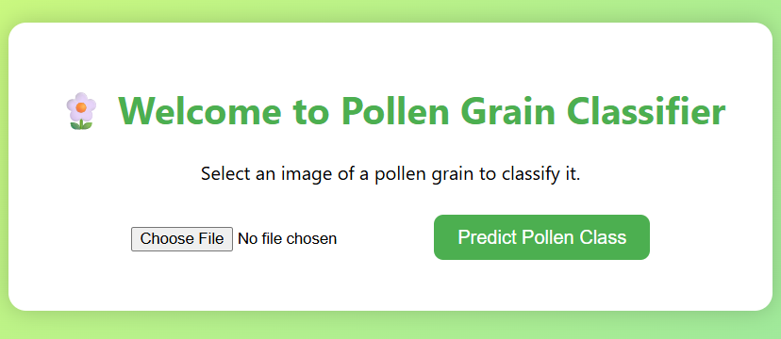

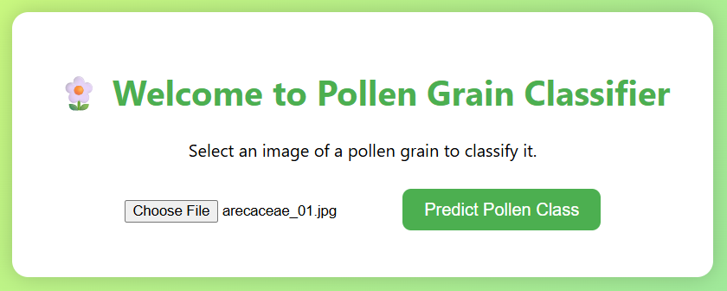

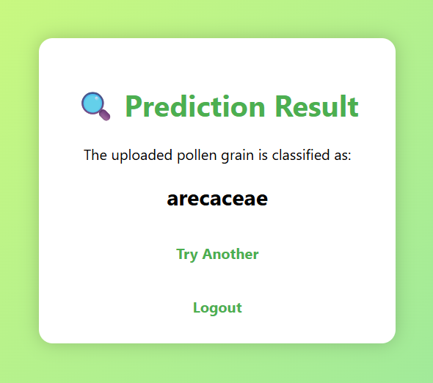



# ADVANTAGES AND DISADVANTAGES

**Advantages:**

* **Automated Pollen Identification**  
  The model enables fast and accurate classification of pollen grains, reducing the reliance on manual microscopic analysis by experts.
* **User-Friendly Interface**  
  The web-based interface built using Flask is clean, intuitive, and accessible, even for users with minimal technical background.
* **Multi-Class Prediction**  
  The model classifies pollen into multiple species or types, enabling broader application in allergy diagnosis, biodiversity studies, and crop research.
* **Time-Saving & Cost-Effective**  
  By providing instant predictions through uploaded images, the system eliminates the need for specialized lab tools and long processing times.
* **High Model Performance**  
  The CNN model demonstrates strong training and validation accuracy, offering a stable and scalable image classification solution.
* **Visual Output Support**   
  The system can optionally display example images of predicted classes, aiding researchers and students in comparing and verifying predictions.

### Disadvantages:

* **Limited to Image Input**  
  The model only works with clear, labeled images and cannot process additional environmental or contextual data (e.g., location, time, or text notes).
* **Image Quality Dependency**  
  Prediction accuracy may drop if the uploaded pollen grain images are blurry, poorly lit, or not captured under proper microscopic conditions.
* **Dataset Limitation**  
  The model is trained on a specific set of pollen types. It may underperform or misclassify new or rare pollen species not present in the training data.
* **Standalone Deployment**  
  The system currently operates independently and is not integrated with research databases, agricultural monitoring systems, or clinical records.
* **Security & Privacy Concerns**  
  Although image data is processed in real-time, storing or sharing images without proper encryption or access controls may raise data privacy issues in certain deployments.

# CONCLUSION

This project successfully demonstrates the integration of deep learning in environmental, medical, and agricultural image analysis. By combining automated image classification with a user-friendly web interface, it provides a scalable and efficient tool for identifying pollen grain types based on visual characteristics.

The pollen classification system, developed using Convolutional Neural Networks (CNN), highlights the powerful potential of data-driven solutions in fields such as biodiversity research, allergy diagnostics, and crop management. The interactive Flask-based web application ensures that both experts and non-experts can access accurate predictions in real time.

This project not only showcases the strength of AI-powered visual recognition but also emphasizes the value of accessible technology in transforming traditional, expert-dependent processes. By enabling quick, reliable, and class-specific pollen identification, the system supports more informed decision-making in research, healthcare, and agriculture.

# FUTURE SCOPE

• **Model Generalization with Larger Datasets**  
To improve robustness and accuracy, future versions can be trained on more diverse pollen datasets collected from different ecological zones and microscopy sources.

• **Integration with Environmental & Agricultural Systems**  
The system can be integrated with biodiversity databases or agricultural monitoring tools to support real-time ecological and crop health assessments.

• **Mobile App Development**  
Developing a mobile-friendly version would enable field researchers, farmers, and students to classify pollen grains directly from their mobile devices.

• **Advanced Multi-View Image Analysis**  
Incorporating 3D or multi-angle microscopic image inputs could enhance classification accuracy, especially for morphologically similar pollen types.

• **Multi-Application Expansion**  
The model can be extended to classify other types of microscopic particles such as spores, fungal elements, or even dust pollutants.

• **Improved Image Preprocessing**  
Future iterations can include automatic enhancement and segmentation of images to better handle blurred, noisy, or low-resolution inputs.

• **Security and Data Privacy Enhancements**  
To ensure safe deployment, especially in health or academic settings, future versions should include encryption, user authentication, and data usage transparency.

# APPENDIX

### Source Code:

### 

Dataset Link:

<https://www.kaggle.com/datasets/andrewmvd/pollen-grain-image-classification>

Project Demo:

<https://github.com/GanduKavya/Classification-of-Pollen-Grains.git>